

Whitepaper
Information Worker Competence Center -
Achieving Business Success with your Collaboration Infrastructure

Simone Ruppertz-Rausch, May 2009
Simone Ruppertz-Rausch
Microsoft IW Business Strategy Consultant

For more information, e-mail iwbscinf@miscrosoft.com.

The information contained in this document represents the current view of Microsoft Corporation on the issues discussed as of the date of publication. Because Microsoft must respond to changing market conditions, it should not be interpreted to be a commitment on the part of Microsoft, and Microsoft cannot guarantee the accuracy of any information presented after the date of publication. This White Paper is for informational purposes only. MICROSOFT MAKES NO WARRANTIES, EXPRESS, IMPLIED OR STATUTORY, AS TO THE INFORMATION IN THIS DOCUMENT. Complying with all applicable copyright laws is the responsibility of the user. Without limiting the rights under copyright, no part of this document may be reproduced, stored in or introduced into a retrieval system, or transmitted in any form or by any means (electronic, mechanical, photocopying, recording, or otherwise), or for any purpose, without the express written permission of Microsoft Corporation.
Microsoft may have patents, patent applications, trademarks, copyrights, or other intellectual property rights covering subject matter in this document. Except as expressly provided in any written license agreement from Microsoft, the furnishing of this document does not give you any license to these patents, trademarks, copyrights, or other intellectual property. Unless otherwise noted, the example companies, organizations, products, domain names, e-mail addresses, logos, people, places and events depicted herein are fictitious, and no association with any real company, organization, product, domain name, email address, logo, person, place or event is intended or should be inferred.

© 2009 Microsoft Corporation. All rights reserved. Any use or distribution of these materials without express authorization of Microsoft Corp. is strictly prohibited. Microsoft and Windows are either registered trademarks of Microsoft Corporation in the United States and/or other countries. The names of actual companies and products mentioned herein may be the trademarks of their respective owners.

Table of Contents
Abstract 4
Introduction 4
What is an Information Worker Competence Center (IWCC)? 5
Our Understanding of Customer Needs 6
Getting Started 7
Organizational Structure of an Information Worker Competence Center 9
Organizational Model 9
Programmatic Pillars of the IWCC 9
Governance across Business and IT 10
Steering Board 11
Project Management Office 12
Business focused IWCC activities 13
IT focused IWCC activities 18
Resources and Roles 21
Challenges along the way 22
Reference Cases 23
Oil and Gas industry 23
Manufacturing 24
Key Recommendations 24
About the Author 26
References 27

Abstract
Competence Centers are the standard approach to managing shared business infrastructures such as Enterprise Resource Management and Business Intelligence. With the increasing importance of team and collaborative work we adopt a similar approach. Many organizations are now responding to the growing demand for collaboration by managing their infrastructure in this way. Investments in the collaboration realm are not just about the IT solution but about implementing IT-enabled change especially since “Business Value is generated by what organizations do with IT rather than by the technology itself”. This is especially valid for the latest Web 2.0 technologies providing strong bottom-up elements engaging a broad base of workers through communities, ad-hoc projects, team work and social networking.
This Whitepaper outlines the functions an Information Worker Competence Center should include and in return what contributions to business success you should expect.

Introduction
As far back as 2004, Forrester Research stated, “Competence Centers normally start from pain.” This is due to the fact that usually the following effects can be observed in organizations:
- Runaway user requests: User-requests continue to mount and grow exponentially once the availability of the service is discovered.
- Lack of internal coordination of solutions: There are multiple Information Worker solutions and experiences, but expertise is not being properly leveraged and overlapping services and point solutions usually mushroom.
- High cost and unstructured on-going support: Dependency on external support; challenges are not being handled adequately requiring third-party help at higher costs.
- Unclear business return on IT investment: Little or no oversight on benefits/value-add of IT investment to the business; lack of measurement.
  - Little impact on existing schedules and milestones: A coordinating function that stringently prioritizes portfolio decisions and has oversight on running projects does either not exist or does not work properly as a decision broker.
- Lack of focused coordination with Vendors, Suppliers or Partners: Insight on resources available (for example from Microsoft, the latest updates or participation in product cycles) does not exist or is not leveraged to advantage.
A Competence Center that focuses on Information Worker needs will address these issues in a vendor neutral way and ultimately has three stated premises: (1) fuel business differentiation, (2) provide reassignment and refreshment, and most importantly (3) measure and deliver tangible business value.

What is an Information Worker Competence Center (IWCC)?
An Information Worker Competence Center (IWCC) is a coordinating function providing strategic oversight and decision levers across its portfolio of programs. As an administrative entity it logically groups “people with interrelated disciplines, domains of knowledge, experiences and skills [...] generally focusing on crucial expertise for the business”. An IWCC becomes, therefore, the focal point to turn to for Information Work related topics.
Such a programmatic approach will allow for
  - strategic development of the Information Worker capabilities within the organization that support business direction and goals,
  - better selection of prioritized projects based on defined criteria, e.g., strategic importance, degree of innovation, expected business benefit, required maturity level, contribution to risk minimization etc.,
  - effective allocation of scarce resource, that is matching the right people and/or partners with the right skills to a project,
  - predictable outcomes and better results due to a managed and consistent approach across the whole portfolio,
  - a well governed, performant and scalable platform based on clear guidelines and principles,
  - efficient operation of your collaboration platform,
  - measurement and control of benefits on the business relevant contributions via a scorecard.

In its interactions, the Information Worker Competence Center aligns (a) upward with the business goals of the company, (b) inward managing the resources and projects and (c) outward networking with other institutions and liaising with its external delivery partners.
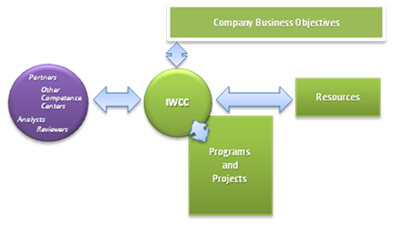
Figure 1: Key interactions of the IWCC

Our Understanding of Customer Needs
Given the desire of many companies to move toward an ‘Enterprise 2.0’ environment, there are many initiatives that must take place in order to effectively enable this progression. These include fundamental change around people, process, workplace and technology. That is, the new and inherently disruptive technologies around e.g., social computing that Information Workers demand in the Web 2.0 context, challenge organizations and their culture. How do you tackle this demand? The goal of an Information Worker Competence Center in this situation is to effectively provide guidance and expertise contributing to the transition toward an increasingly flexible, more adaptive workplace and turning the existing collaboration technology investments into strategic assets.
Now that you understand the key objective of an Information Worker Competence Center, what are the starting steps that need to be considered for implementation?
First of all, you will need a vision statement for your IWCC providing strategic direction - formulating your Information Worker Competence Center vision and strategy starts by clearly understanding the IWCC concept and determining where and how it could be implemented in the organization.
In addition, you need to define its primary goals, objectives and measures of success. Fundamental questions that you would need to answer are:
  - What is the role you intend of the IWCC?
  - Have you considered who would be involved with the IWCC?
  - Have you thought about its structure and form (centralized/decentralized; virtual/real)?
  - Have you considered funding and are you aware of the options?
  - Is your culture attuned to an IWCC philosophy? If not, what are the measures to build awareness?

Getting Started
While an Information Worker Competence Center can provide tremendous value, the challenge is not only how to implement it successfully, but also how to anticipate and analyze its life cycle as it moves through several stages: development, marketing, operation, and retirement or transformation. However, for its implementation there are seven critical success factors that must be set up in the right way straight from the beginning:
- Vision Statement
Set out a clear statement on the strategic direction of the IWCC that will allow alignment of the different components/program elements.
- Prioritization
Portfolio management of projects according to clear prioritization criteria is critical to the success of the competence center. This answers the question, ‘What should be done with available resources?’
- Benefit Management
Provide a framework for realizing the benefits on which the respective projects are justified. Without active management, benefits might not be achieved and investment value might not be verifiable.
- Performance Management
Sets targets for innovation and service delivery of the IWCC that is tracked by a scorecard allowing for continuous improvement in this capacity.
- Skills Management
People are key to success with the goal to gain leverage from high-demand, high-value knowledge, competencies and skills. Resources working within an IWCC should demonstrate (a) a high level of competency in his or her area of expertise; (b) a mixed knowledge of both business and technology; and (c) personal qualities of being service-minded, innovative in their thinking, and apt at teamwork.
- Key Stakeholders
A key component for success is management sponsorship. Establish regular reports to and participation in IWCC board meetings by the management sponsor. Critical key stakeholders from the business are your project requestors – you will need to ensure a communication plan is in place and their continued participation in all relevant project efforts is secured.
- Risk Management
Typical risks that need attention and mitigation measures are associated with the organizations’ readiness to cope with change. Risks on the project level usually include e.g., business continuity, technical, cost, schedule, resource availability, operational support, quality, and supplier failure issues.

Organizational Structure of an Information Worker Competence Center
From an organizational model point of view an IWCC can take three different forms – as there is no ‘one size fits all’ approach for this, you have to decide which of the following options aligns best with your existing organization. Independent from the setup you are choosing, the IWCC’s programs identify, build and leverage best practices in areas of expertise, and help deploy people effectively, whether internal staff, external staff or a blend. Thereby the IWCC consolidates and ‘lends out’ adequate knowledge and expertise to the requested projects.

Organizational Model
There are three main options on how to organize the Information Worker Competence Center:
- Physical group: Forming the IWCC as a discrete group of people covering the different disciplines/programs.
- Virtual group: Operating with a virtual team makes it necessary to have a core team as the ‘hub’ of the IWCC in place, which then draws upon the specific skills and competencies from across the company’s organization to fulfill the requirements. In this setup they can span time zones, continents and corporate entities.
- Federated group: This model can either be physical, virtual or a combination of both. Usually a federated structure is suited for organizations working especially with satellite operations.
What are the different disciplines or programs of which an Information Worker Competence Center should be comprised?

Programmatic Pillars of the IWCC
A fully-matured IWCC would consist of ten elements in order to provide Information Workers with the solutions they require. Depending on your current situation and organizational prerequisites you could start with a limited approach of forming an IWCC by incorporating already-existing disciplines such as Operations and Technical Support - even if delivered by an outsourced resource - with the goal to build up the remaining disciplines over time.
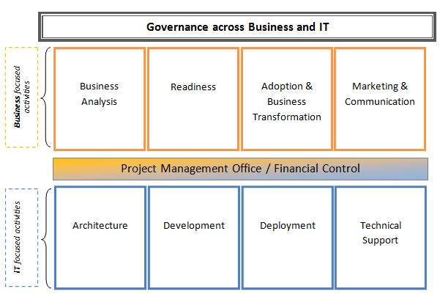
Figure 2: Disciplines covered by an Information Worker Competence Center

Governance across Business and IT
The starting point of your endeavors should be in the establishment of the Governance model and process – this will help you to establish control over your collaborative space and will help to ensure consistent audit and compliance.
In order to achieve this, the Governance discipline is responsible for driving four key governance areas: this will build up and maintain a governance plan that caters to the needed/most appropriate policies and procedures for operating the Information Worker infrastructure so that business value can be realized across the organization based on common standards; the Governance program will also describe and clearly delineate roles and responsibilities as well as governing bodies needed to operate the infrastructure. Domains where the output of the Governance program applies are e.g., document management, social networking etc.
Also, the Governance program takes care of applying corporate communication policies for a user-friendly information architecture.
From a structural viewpoint the following outline could apply: 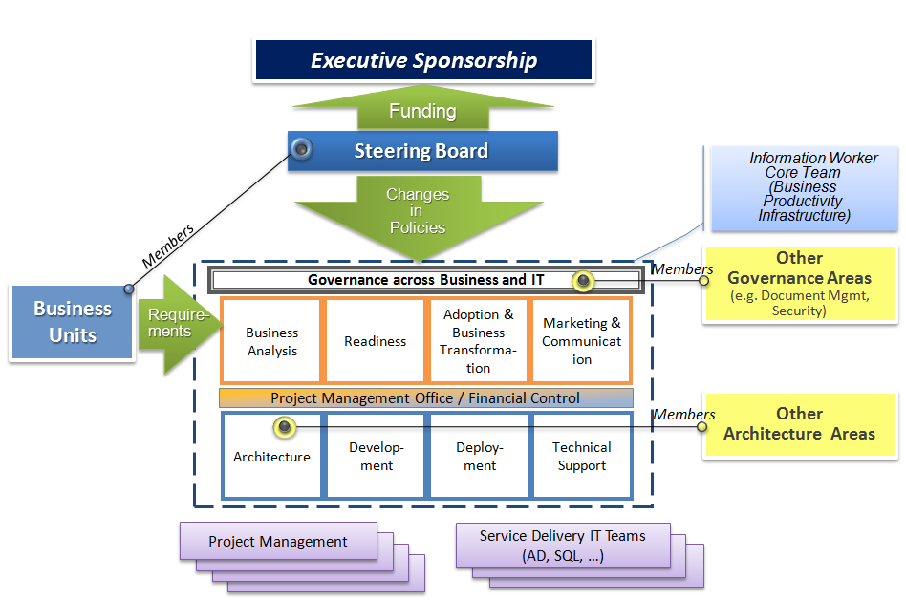
Figure 3: Governance Structure for an IWCC

Steering Board
A Steering Board comprises the following positions: Chair of the Steering Board, key representatives of the different program disciplines and from the Service delivery side, a Security as well as Business Unit representatives. Overall, its main function is to regularly report to the management on activities of the IWCC according to its strategic directions, such as performance measurement of the IWCC based on key indicators such as internal customer satisfaction with service delivery, benefit achievement, continuous program improvements based on best practices and ongoing learning, overall project landscape aligned with an adoption scorecard, etc.
Specific responsibilities of the Steering Board Chair embrace the alignment of business objectives with the collaboration environment and services delivery, the justification of further investments required to enable the businesses to drive value, resolving project conflicts and priorities as well as representing the future collaboration vision. Whereas the Business Units representatives will contribute to strategic decisions of the Steering Board by representing the needs and requirements of their respective business teams and users; the Security representative is the expert on topics such as security and compliances policies, access control, information as well as network and server protection.
The Steering Board will also regularly align with other Competence Centers, that might exist but with a different vendor focus and/or if this is the case, Business Unit specific Information Worker Competency Centers with a replicating satellite function.

Project Management Office
As a coordinating body, a Project Management Office functions as the ‘moderator’ between the technical and business related activities. It needs to ensure that the right projects are chosen and prioritized, chartered and scoped properly, and helps with their timely and effective delivery via a centralized yet ‘matrixed’ project management approach.
Guiding principles to the Project Office are:
- Provide a project request tool that requires the project requestor to apply S.M.A.R.T. principles to his/her request
- Customer management: Collect, prioritize and align project requests
- Forecast demand and manage appropriate resources/staffing
- Put a communication plan in place and establish good working relationships with key contacts
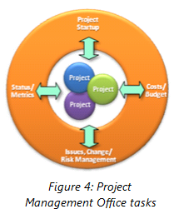
- Estimate, manage delivery, and measure project success
- Monitor program risks, issues and changes
- Manage decision-making process
- Capture and share project intellectual capital
- Maintain standards for all projects
- Quality assurance: Evaluate, track and report project
performance, also managing the relationship between
‘interrelated’ projects
- Resource oversight and team performance
- Coordinate License Management
- Financial Control, cost allocation and chargeback: Monitor, verify and pass on project-related charges to the internal cost center of the requester using a chargeback model.

Business focused IWCC activities

Business Analysis
The business analysis discipline’s main focus is to manage change requests from business, identify, collect and understand the requirements expressed by business, and ensure change is in-line with the IT capability roadmap. It is the Business Analyst who will help formulate a project request/business case together with the business owner in case no shared best practice or use case scenario already exists. To perform these business analysis tasks a set of techniques is required to determine the best solution to the respective business challenges. These techniques deliver insight on such Information Work aspects as company culture, work styles, user types, skills outlines, capability maturity, and benefit statements.
As Gartner (2003) has put it, “The process enablement team’s primary relationship will be with the users and super-users of the business community. This team will play a critical role in the development, measurement and performance of service-level agreements, and will assume the primary responsibility for developing and prioritizing the [business] requirements for other teams in the competence center.” The discipline, therefore, will contribute to continuous improvement along the company’s value chain. This will help to resolve business pain points surfacing during the daily work of an Information Worker.
The Business Analysis stream works with mock-up presentations (supporting a rapid development approach), proofs of concept and pilots, helps building new best practices and defining appropriate Readiness materials. Also, in order to best cater to the needs of Information Workers, it may well be the Business Analyst who keeps the IWCC up-to-date with latest insight on technological news, independent analyst evaluations etc.
Key Responsibilities of the Business Analysis discipline are:
- Understand strategic goals and objectives of the business
- Work with the business to identify, collect and understand their requirements
- Outline the business scenarios for (a) resolving business pain points and (b) driving new ways of working
- Define success measures
As a recent study of the CIO Executive Board (2008) shows, engaging with the business is the most important IT governance capability; it is also the least developed.
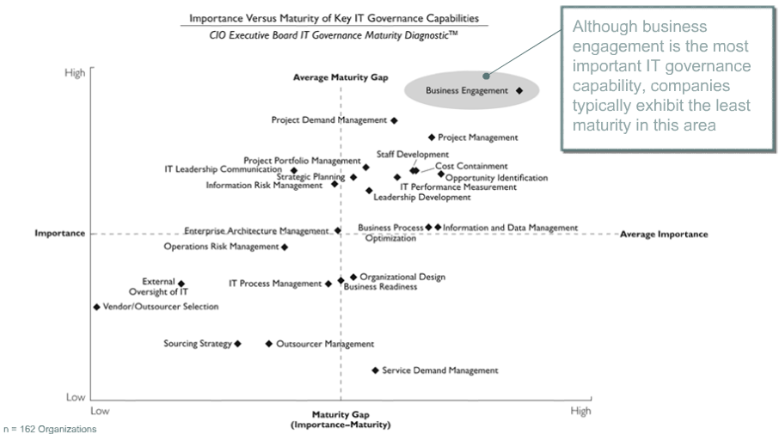
Figure 5: Governance Maturity Assessment

Readiness
To enable a smooth, fast and purposeful usage of new solutions or systems, material that provides guidance is necessary. Such readiness materials can have different formats: Video- or Screencasts, Podcasts, Frequently Asked Questions Sessions, Face-to-Face hands-on trainings, laminated quick reference cards, PowerPoint presentations, etc.
Preparing, collecting or repurposing existing materials are the Readiness stream’s main responsibilities. In order to do this, the Readiness stream builds on the insights gained by the business analyst who identifies and outlines the business scenarios that provide, for example, insight on cultural change needed as well as general and specific technical skills needed to fully-leverage the business benefit of the implemented scenario.

Adoption and Business Transformation
Innovation and change are driven through scenarios that provide rich detail on the new ways of working. The Adoption and Business Transformation stream leverages the appropriate readiness format and material that has been crafted based upon scenarios and applies it accordingly. That is, these change activities are readiness measures that communicate/train the effective and efficient use of solutions within the context of the business, culture, work styles, user types and business goals.
Often outside training does not effectively convey the business context, but merely focuses on pure feature and function training. Business Transformation activities from within the IW Competence Center will be able to deliver both: end user readiness training within the business context, super user training and readiness for program or project team members.
In this regard the Business Transformation stream helps to drive innovation that is, supporting ‘new ways of doing something’ - the goal of innovation is achieving positive change, to make someone or something better. Innovation leading to increased productivity is the fundamental source of increasing wealth in an economy.
The change agents can also be effectively used to gather information on what is difficult to use and what is difficult to teach. This feedback is an important quality indicator to the IW Competence Center about the solutions, processes and the platform.
Key Responsibilities of the Business Transformation discipline are:
- Define training and coaching principles
- Define and deliver project/solution related training and coaching activities
- Contribute to Marketing Program (Road Shows etc.)
- Apply success measures and reporting
- Act as Quality Assurance entity for the project
- Have a continued end-user improvement plan in place
- Contribute to a Knowledge Management repository
- Supervise Change Management processes and measures
- Create online forums where users can support each other and ask questions
- Create opportunities for face-to-face learning in unstructured or semi-structured environments, such as blogs, lunch and learns or after hours discussions
Demonstrating the value of information worker capabilities can take numerous forms. The most prominent form, the business case, is critical to driving adoption. Based on survey data, Forrester Research has stated that the lack of a business case will slow down adoption, while a strong business case will help speed up adoption. Once business decision-makers are aware of the potential opportunity of new information worker capabilities, a business case should be able to quantify those benefits. The business case should contain both quantitative measures (such as ROI) and qualitative measures (such as alignment to strategic imperatives). Business decision-makers must be able to demonstrate to their management how solutions will support and provide value to their key business initiatives.

Marketing and Communication
In large enterprises it is advantageous to have dedicated resources that market the platform in scope from within an IWCC to the enterprise at large. However, it is not the job of such a Marketing and Communication team to do hard sells.
Rather, the IWCC Marketing and Communication group position the solutions within the context of the enterprise. The stream is informed on the continuously-proposed projects and holds road shows on best practice solutions, demonstrations and hosts information forums. Such measures fostering transparency and exchange on ‘what is around’, will not only raise general interest but drives acceptance and accelerates change towards the new ways of collaborative working.
Other responsibilities of a Marketing and Communication team belonging to the Information Worker Competence Center are:
- Publish all information about the services offered by the IWCC in a transparent, inclusive way, open and asking for feedback at all stages
- position and promote the IWCC as the go-to resource
- promote and share business value assessment results
- promote and share knowledge and best practices
- contribute to increased acceptance and higher adoption rates
- disseminate information on updates, e.g., new functionalities
- collect feedback for future strategic decisions

IT focused IWCC activities

Architecture
The Architecture discipline is responsible for managing the logical architecture and defining service levels; the logical architecture should precede any physical design or network planning. The stream will also make sure that the different solution architectures will adhere to the enterprise architecture and follow the agreed architecture principles and best practices.
However, defining the information architecture principles in alignment with the Architecture program falls in the responsibility of the Governance discipline.
Core responsibilities of the Architecture discipline are:
- Defining the overall software and logical infrastructure architecture, such as
  - Service delivery approach
  - Standard vs. Customizable environments/farms
  - Development vs. Staging vs. Production environments/farms
  - Management of the application portfolio

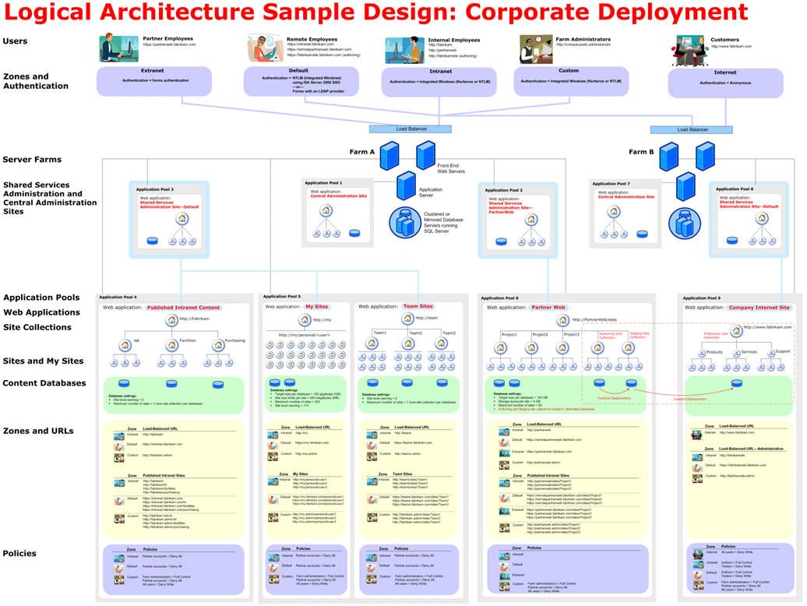
Figure 6: Design Sample: Corporate Deployment Logical Architecture

Development
This stream identifies and approves custom development projects; development of solutions might be performed in-house or through a development partner. Following the Microsoft Solution Framework (MSF), for example, the development phase of a solution begins with the first iteration of development and culminates with the functionality complete milestone (or Beta release).
In general, the Development capacity of the IWCC is fulfilling the following functions:
- Build standardized components
- Enforce a consistent development methodology such as the Microsoft Solution Framework
- Provide and ensure configuration and customization guidelines and best practices
- Coach and train developers, engineers and administrators
- Ensure reusable design of custom components
- Help to prioritize and coordinate development requests with the Project Office and give feedback on the evaluation of ‘Build vs. Buy’ scenarios

Deployment
The Deployment discipline consists of several interrelated activities; performing the deployment is the last step within the Microsoft Solution Framework (MSF).
- Apply standardized provisioning processes and tools
- Take care of configurations and change management requests
- Deliver best practices, quality assurance guidelines, and reviews for solutions to be deployed according to a release management
- Follow pre-deployment (compatibility) testing procedures
- Perform performance, scalability and security audits
- Provide feedback to other groups/solution developments
- Deliver an excellent deployment experience to consumers

Operations and Technical Support
Primary focus is on building and maintaining the operations based on the outlined governance model. This discipline includes all of the service-level management and interfaces to service providers covering both in-house and cloud service provision.
For the support function one of the main tasks within is to handle questions and problems relating to the Information Worker infrastructure. In smaller teams the questions may be directly posed to the experts or so-called ‘super users or champions’ being part of the business. In larger teams it is generally necessary to establish a tiered support structure. In this case a support desk equivalent to the second level in a three-tier support structure needs to be established. The support desk usually has the same kind of expertise as the Operations core team of the IWCC, but at a less expert level.
The support desk handles questions that the tier one help desk cannot answer and passes the very difficult or extremely urgent issues on to the tier three or core teams. In most organizations, first-line support is generally secured via the super users/champions within the business groups. The actual help desk within the IWCC remains very small and feeds to the continuous learning of the overall center, monitors support statistics and adjusts readiness accordingly.
Responsibilities of the Operations and Technical Support discipline are:
- Service-level management and charge back
- Create an effective support system with proper channels of escalation
- Respond to application questions, bugs, and other problems requiring issue resolution
- Provide typical, for example, SharePoint administration roles such as:
  - Provisioning site for end users
  - Assigning security permissions to users and groups

Resources and Roles
As outlined in the section on the organizational model, different options exist in staffing an Information Worker Competence Center. That is, you can draw upon a physical and or virtual team, meaning that resources could also be ‘lent out’ or procured from other organizational units. However, different skills, roles and perspectives are required in covering the different disciplines - depending on your breadth of implementing an IWCC, i.e., following a phased approach in first building up certain disciplines with the rest to follow or initiating a full-fledged implementation approach.
Each role does not need to be a person, but all core skills should be covered as soon as possible. Minimal core skills in this regards are the Project Manager, Business Analyst or Consultant and at least a Technical Architect or Consultant. Development and operations are separate streams run either in-house or in an outsourced fashion. For an IWCC organizational setup the following roles are in scope:
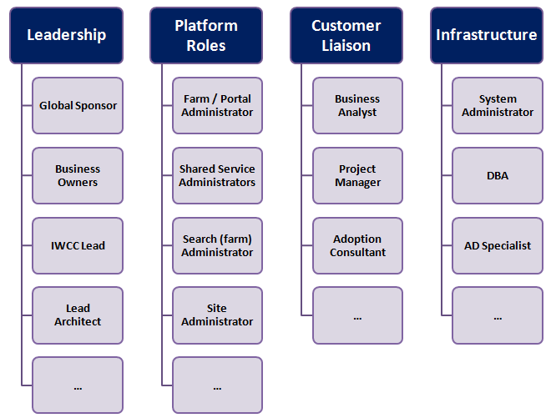
Figure 7: Resources and Roles for a fully-implemented IWCC

Challenges along the way
Building an Information Worker Competence Center might be accompanied by a number of challenges – we want to bring some of these core challenges to your attention providing the opportunity to plan accordingly:
- It takes time to care for the evolution from setting the IWCC up at the best place in the organization to its unfolding as a mainstream go-to resource.
- Resource Management in terms of managing infusion, refreshment and departure of people, knowledge and skills always having the ‘right’ skills available without facing bottlenecks of resources or projects.
- Handling matrix reporting relationships.
- For a virtual organization model: Navigating through the cultural, political and behavioral issues around resource sharing; in general: building an effective team to deliver projects.

Reference Cases
The following exemplary outlines will give you an idea on how other customers have approached the topic of implementing an Information Worker Competence Center successfully.

Oil and Gas industry
Goal: Provide software development only, when needed; standardized and automated Operations 7x24; have a decentralized administration in place; high scalability and high availability of the system.
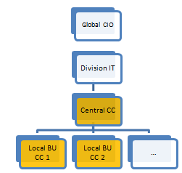
Scope: Sponsorship out of Shared Service Center; providing global operating services for approximately 40’000 users; currently 1’500+ Top Level Sites.
Figure 8: Organizational Structure example from the Oil & Gas industry
Organizational Structure: competence center forms the hub for local business unit-specific competence centers.
Services: Rapid Application Design Consulting can be requested; site template based on CI exists; site directory with high-level processes, location, organization and keyword search exists based on required metadata input from site request; linkage into existing SAP Enterprise Portal; site-wizard automates and supports site requests by the users; site approval processed by the competence center.
Financial Model: Chargeback to customers on (a) Price per number of Workspaces provided; (b) Price per Megabyte; (c) Consulting Fees per request.

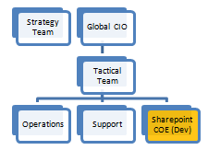
Manufacturing
Goal: Focus on a global design; rules-based approach (i.e., rules exist for each dimension of the infrastructure).
Scope: Global SharePoint Deployment; Competence Center to promote and manage best practices; Global Design from Enterprise Architecture Team; provide global services for approximately 80’000 users; being strategic and tactical, i.e., close to business.
Figure 9: Organizational Structure example from Manufacturing industry
Organizational Structure: Strategic Team comprised of Business Users spread globally.
Services: Consulting for Application scoping with the business; compliance reviews to adhere to the global design; management of development projects done by offshoring partner; maintenance and support.
Financial Model: Mix between central cost center and project based chargebacks.

Key Recommendations
- Importance of establishing a cross functional view, common terminology and approach for capturing demand and for describing requirements and solutions. This ensures keeping Business and IT aligned as well as a joint focus on value generation.
- Importance of Information Worker Capabilities. Collaboration capabilities are increasingly becoming the focal point for competitive differentiation. Focus on the capabilities that your Information Workers need for their daily activities consistently delivered by an IWCC.
- Enforcing technology standards. Leverage what you have in your portfolio and build upon it. That will help you to avoid and cut costs as well as leverage undiscovered business value of your infrastructure portfolio.
- Rely on an incremental approach. Build on what works e.g., in other departments or organizations leveraging the expertise and existing knowledge/solutions. This approach leads to quick and already-proven wins. It will, furthermore, allow you to quickly discard what is not working. In this light, process improvements to Information Worker pain points can be understood.
- Prioritization. Transparency due to business cases and ranking projects according to your company’s’ business goals and driving initiatives.
- People mix (IT/Business). Staffing is critical; therefore you will need to take care that your different programs can draw upon the appropriate set of skills.
“Competency centers assume flexibility and replenishment of knowledge, assignments and learning. They serve as channels through which project and practice managers, business customers and line managers can fulfill projects, teams and business initiatives. Most important, competency centers continually generate and refresh knowledge, competencies, practices and skills.” (Gartner 2002)

About the Author
Simone Ruppertz-Rausch is a business consultant with experience in capability analysis, collaboration strategy and process re-engineering projects for global companies. She is currently a member of Microsoft’s Information Worker Business Strategy Consulting Group that is focused on driving adoption of Microsoft’s Office System to address key customer business challenges. Simone has been a research associate and held various positions in the Banking and Chemical Industries.

References
- Byron Miller, 2004: SAP Customer Competence Center – Competencies and Organization. Forrester Research Inc.
- Diane Morello, 2002: CEO and CIO Update: Competency Centers Can Build Competitive Advantage. InSide Gartner (IGG-08072002-03).
- Brian Zrimsek, Derek Stephen Prior, 2003: Management Update: All Business Applications Need Competence Center Support. InSide Gartner (IGG-09172003-03).
- IT Governance Institute, 2006: Enterprise Value: Governance of IT Investments.
- Max Mckeown, 2008: The Truth About Innovation. Pearson/Financial Times.
- Microsoft Solution Framework (MSF): http://go.microsoft.com/fwlink/?LinkId=123604
- Jon Greville, 2008: Whitepaper – Realizing the New World of Work. Microsoft Corp.
- Robert H. Schaffer/Harvey A. Thomson, 1998: Successful Change Programs Begin with Results. Harvard Business Review.
- Michael Sampson, 2009: Seamless Teamwork. Microsoft Press.
- CIO Executive Board, 2008: IT Governance Maturity Diagnostic.
- Kerstin Stolzenberg/Krischan Heberle, 2009: Change Management. Springer.
- Infrastructure Planning – Designing a Logical Architecture (http://go.microsoft.com/fwlink/?LinkId=133525)
- SharePoint Server Developer Center (http://go.microsoft.com/fwlink/?LinkId=133506) on MSDN
- Office Deployment Guide (http://go.microsoft.com/fwlink/?LinkId=15721)
- Design Sample Corporate Deployment Logical Architecture (http://go.microsoft.com/fwlink/?LinkId=82151

IT Governance Institute, 2006: Enterprise Value: Governance of IT Investments, p. 10
Gartner 2002 (IGG-08072002-03)
For example, Governance Resource Center for SharePoint Server 2007 (http://go.microsoft.com/fwlink/?LinkID=92729)
S.M.A.R.T. stands for : Specific, Measurable, Achievable, Relevant, Time framed
A solution can include one or some of the following components: adjustment of an existing application, leveraging a system in the proper way, or develop a new application, process improvement or organizational change.
CIO Executive Board IT Governance Maturity Diagnostic, 2008
Average number of users coached by a super-user is contingent on such aspects as (a) time you want the super-user to spend on the topic, (b) media he/she could/should be using and keeping up to date, (c) can he/she be called up in an ad-hoc fashion, (d) does he/she offer workshops or best practice sessions, (e) an online FAQ lists etc., (f) what is the organizational structure and regional spread of people he/she would need to take care of, (g)is there a ‘split’ or specialization according to scenarios etc.
It may refer to incremental, radical, and revolutionary changes in thinking, products, processes, or organizations. A distinction is typically made between invention, an idea made manifest, and innovation, ideas applied successfully (Mckeown 2008)
See also: http://go.microsoft.com/fwlink/?LinkId=157216
Microsoft 2008: Whitepaper – Realizing the New World of Work
Stolzenberg/Heberle, 2009, p. 61 cont.
See for example as a references on logical architecture components, planning of a shared services architecture, example solution architecture etc.: Design logical architecture (http://go.microsoft.com/fwlink/?LinkId=133525)
Please see for the original Visio file: http://go.microsoft.com/fwlink/?LinkId=82151&clcid=0x409
See for example the SharePoint Server Developer Center (http://go.microsoft.com/fwlink/?LinkId=133506) on MSDN
See for example the Office Deployment Guide: http://technet.microsoft.com/library/bb490137.aspx
Schaffer/Thomson, 1998

